**PROFIT & LOSS**



1. An article is bought for 600/- and sold for 750/-. Find the gain%



1.20 2.25 3.27.5 4.30 5.50



1. An article is bought for 450/- and sold for 400/-. Find the loss%

1.11 1/9 2.10 3.9 1/11 4.8 5.12

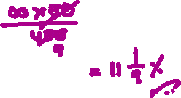

1. A man bought an article for 640/- and sold at a profit of 15%. Find the selling price

1.673 2.678 3.736 4.784 5.684



1. A plot is bought for 28,00,000 and sold at a profit of 14 2/7%. Find the selling price in lakhs



1.30 2.31.5 3.32.25 4.36 5.32



1. A man sold a box for 450/- at a gain of 25%. Find the cost price

1.400 2.425 3.350 4.360 5.380

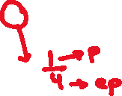

1. An article is sold for 375/- at a loss of 6 ¼%. Find the cost price



1.400 2.380 3.381.25 4.360 5.350



1. A bought a ring and sold it to B at 10% profit and B sold it to C at a loss of 20%. If C paid 22,000/-, for how many did A buy it?

1.20,000 2.22,500 3.25,000 4.27,750 5.28,000



1. The cost price of an object is numerically equal to its profit % and its selling price is 56/-. What is its cost price?

1.20 2.36 3.40 4.50 5.48



1. The profit obtained by selling an article for 56/- is same as the loss obtained by selling it for 42/-. What is its CP?



1.49 2.50 3.48 4.46 5.54



1. The profit obtained by selling an article for 480/- is twice the loss obtained by selling it for 330/-. What is the CP?



1.420 2.375 3.360 4.380 5.400



1. A man sold 2 articles for 495/- each. On one he gains 10% and on the other he losses 10%. Find the total loss.



1.4.95 2.5 3.9.90 4.10 5.10.50

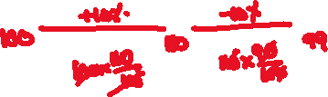

1. The cost price of 3 articles is same as the selling price of 2 articles. What is the loss or gain%?

1.50% loss 2.50% gain 3.25% loss 4.25% gain 5.60% gain



1. A man bought every 12 articles for 10/- and sold every 15 articles for 12/-. What is the loss or gain%?



1.4% loss 2.4% gain 3.2% loss 4.2% gain 5.8% gain



1. A man sold an article at 10% loss. If he had taken 45/- more, the gain would have been 8%. What is its cost price?

1.150 2.180 3.200 4.250 5.500



1. A man sold an article at a profit of 25%. If he had bought it at 10% less and sold for 10/- more, the gain would have been 40%. Find its cost price

1.800 2.960 3.1000 4.1080 5.1200

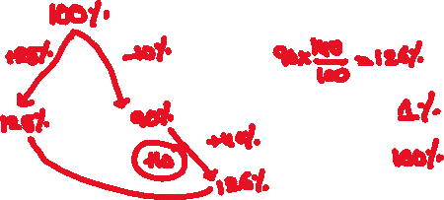

1. A man sold 15 articles and got the selling price of 3 articles as the profit. What is the profit%?



1.12.5 2.15 3.17.5 4.20 5.25



1. A man sold 3/5 of the goods at 20% loss. At what profit% should he sell the remaining goods to get 10% profit on the whole?

1.55 2.50 3.45 4.40 5.60



1. A man bought 2 articles for a total of 840/-. He sold one at 20% gain and the other at 10% loss. Find their cost prices in Rs. If their selling prices are the same.



1.360 & 480 2.480 & 360 3.400 & 440 4.440 & 400 5.380 & 400

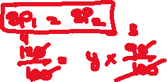

1. A man bought 2 articles for 450/- and sold one at 15% profit and the other at 10% loss. On the whole there is no loss or no gain. Find the cost prices in Rs of the two articles



1.270 & 180 2.180 & 270 3.200 & 250 4.250 & 200 5.220 & 200



1. A merchant professes to sell the goods at cost price but gives 900 gms, instead of a kg. Find the % gain



1.10 2.9 1/11 3.11 1/9 4.12 5.14

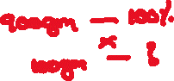

1. A merchant sells the goods at cost price but gets a profit of 25%. How many gms of commodity is given instead of a kg to the customer?



1.900 2.800 3.750 4.720 5.780

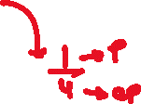

1. A reduction of 20% enables a person to buy five more fruits for 200/-. What is the original price of each fruit?



1.20 2.10 3.8 4.5 5.12



1. By selling 17 articles for 100/-, a man gets a loss of 16%. How many articles should he sells for 100/- in order to get a profit of 19%?



1.12 2.13 3.14 4.15 5.16



1. A man bought a radio at 3/4 of its cost and sold it at 50% above its cost. What is the profit%?



1.200 2.100 3.150 4.50 5.75



1. A man purchased a certain number of apples at 3 for 100/- and same number of apples at 7 for 200/-. He sold each at 39/-. Find the gain%

1.18 2.20 3.25 4.26 5.36

1. A man purchased 14400 fruits at 25/- a dozen. He divided them into three groups according to their size, big, medium, small, in the ratio 5:3:2. He sold big size fruits at 35/- a dozen, medium size at 30/- a dozen and small size at 20/- a dozen. Find the overall gain%

1.20 2.22 3.25 4.27.5 5.25.5

1. Amar sells his house which is worth 48 lacs to Anirudh at 20% profit. Anirudh sells it back to Amar at 5% loss after some period. In this transaction, Amar gets a benefit of Rs

1.1,80,000 2.1,76,000 3.2,40,000 4.2,88,000 5.3,00,000

1. A makes a profit of 25% on the selling price. What is the actual profit%?

1.20 2.25 3.33 1/3 4.40 5.50



1. A man buys a bullock and a cow together for 80,000. He sells the bullock at 20% gain and the cow at 20% loss. On the whole he gains 7.5%. What is the difference between their cost prices?

1.55,000 2.45,000 3.30,000 4.25,000 5.35,000

1. A merchant sells the goods at cost price but cheats the farmer from whom he purchases by 10% and his customer by 10%. What is his overall gain%?

1.19 2.20 3.21 4.21.5 5.24

1. Selling price and profit of a chair are in the ratio 7 1/7: 1 2/3. What is the profit%?

1.30 10/23 2.27 19/24 3.26 11/18 4.24 21/25 5.30 20/23

1. A man sold 2/3 of the goods at 20% profit and the rest at 10% loss. What is the overall profit%?

1.7.5 2.10 3.12 4.12.5 5.14

1. An article is sold at a fixed rate. If it is sold at ¾ of this fixed rate, the loss will be 10%. The gain % by selling it at fixed rate is

1.5 2.10 3.15 4.20 5.25

1. Cost of rice A per kg and cost of rice B per kg are in the ratio of 3:4. They are mixed in the ratio 4:5. Costs of A and B are increased by 20% and 10% respectively. The % rise in the cost of the mixer is

1.12 2.12.5 3.13.75 4.16.25 5.20

**\*\*\*ALL THE BEST\*\*\***